**Proposed code Result of** NetworkTrafficClassification

**Libraries Used:**

Numpy, pandas, matplotlib, seaborn, sklearn, imblearn etc.

**Dataset:**

* Dataset Name: **TotalFeatures-ISCXFlowMeter**
* Dataset link**:** <https://www.kaggle.com/datasets/antoniogarcanoguez/totalfeatures-iscxflowmeter>

**Loading the dataset:**

• Mounted Google Drive to access files.

• Loaded the dataset from **/content/drive/MyDrive/client /TotalFeatures- ISCXFlowMeter.csv** into a Data Frame

**Data preprocessing & EDA:**

• Displayed the first five rows of the dataset using df.head().

• Retrieved dataset dimensions (rows, columns) with df.shape.

• Check unique Value in Columns. d1f['calss'].nunique()

• Checking the Columns name. d1f.columns.

**Label Encoding:**

We have applied label Encoding to convert categorical values to numerical values (for our target feature -“calss”)

• Retrieves and displays the last five rows of the DataFrame **d1f**, helping to inspect recent entries or verify data integrity.

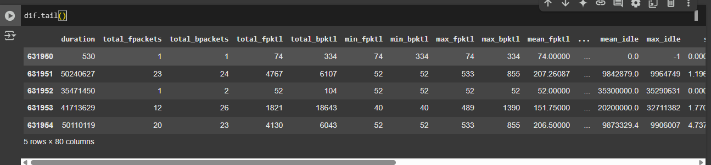

**Null Values:**

We have checked a null values in our dataset does not contain null values.

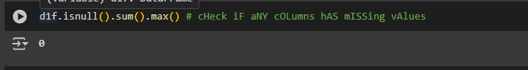

* The first five numerical columns from d1f, plots their histograms with 30 bins using Matplotlib, sets a title, and displays the plot.

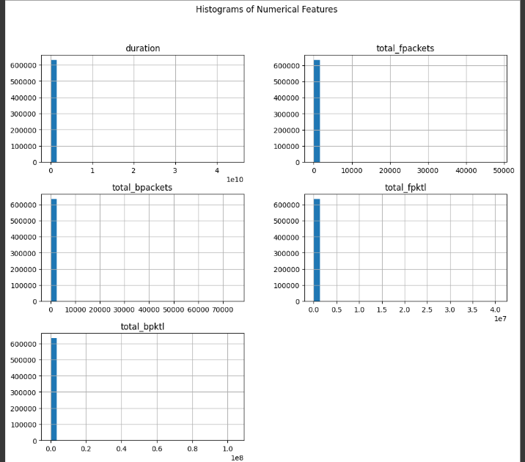

* We have counted the number of class in this four features-

burg_cnt', 'furg_cnt', 'flow_urg', 'flow_cwr', 'flow_ece

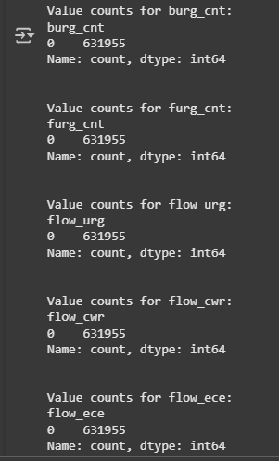

* We drop 4 features because they only contains 1 class Value.

**Correlation matrix:**

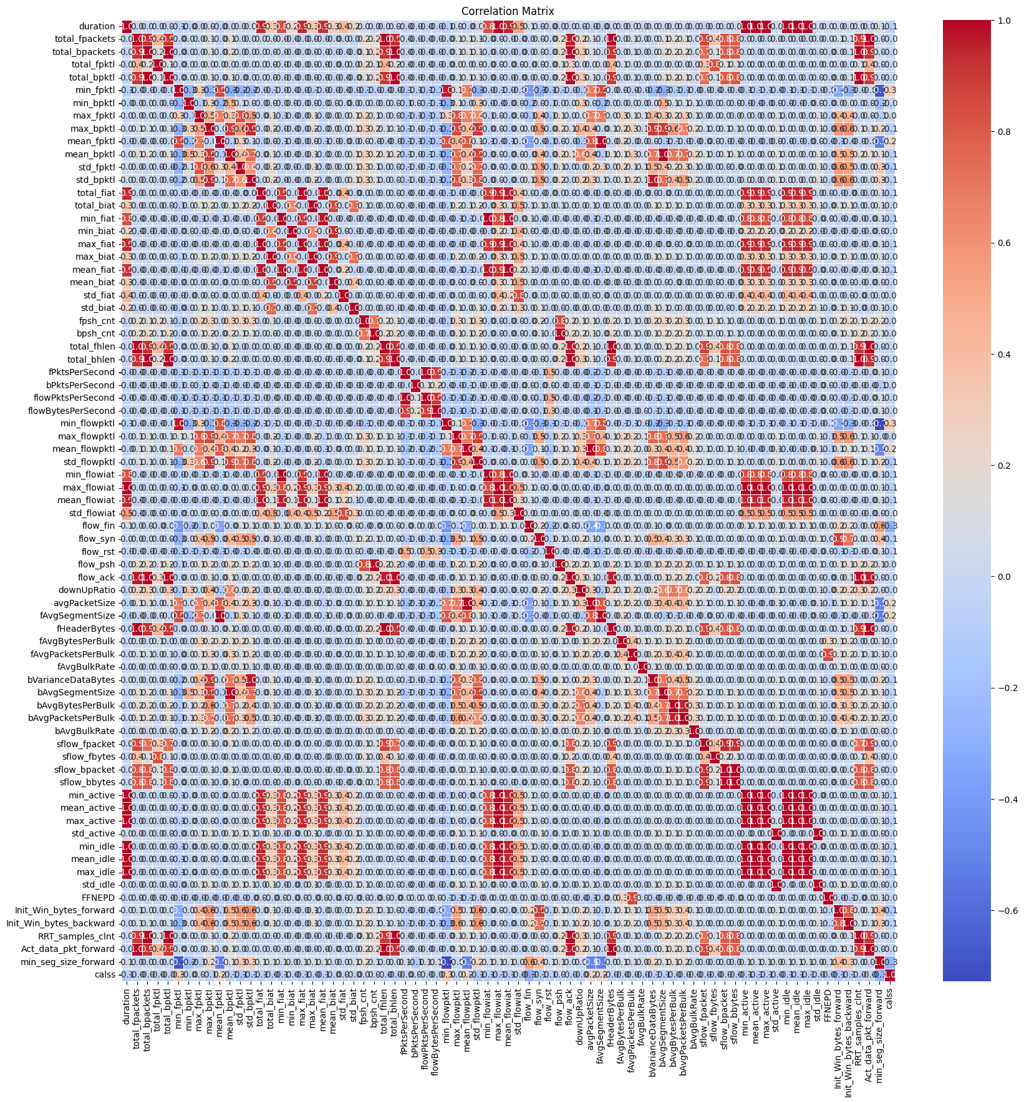

* calculates the absolute correlation of all features in d1f with the target feature 'calss', sorts them in descending order, selects the top 10

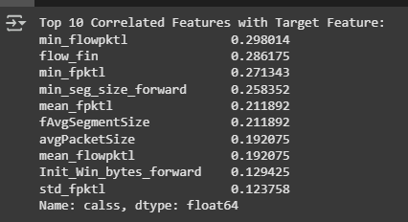

* We creates a bar plot showing the relationship between the target feature 'calss' and 'min_flowpktl' using seaborn, labeling axes and adding a title for better visualization

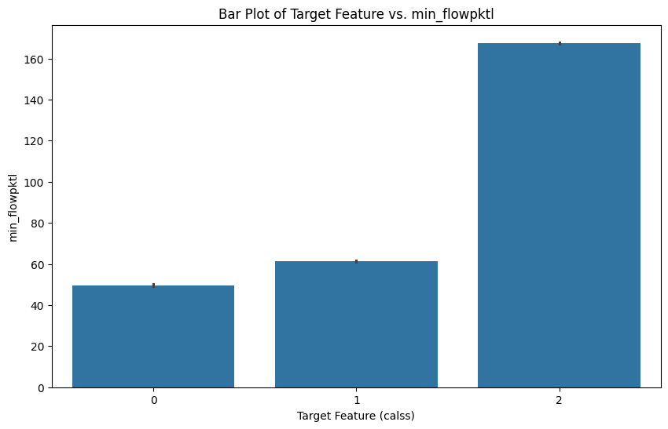

* We creates a bar plot displaying the top 10 features most correlated with the target, labeling axes, rotating x-axis labels for readability, adjusting layout, and showing the plot.

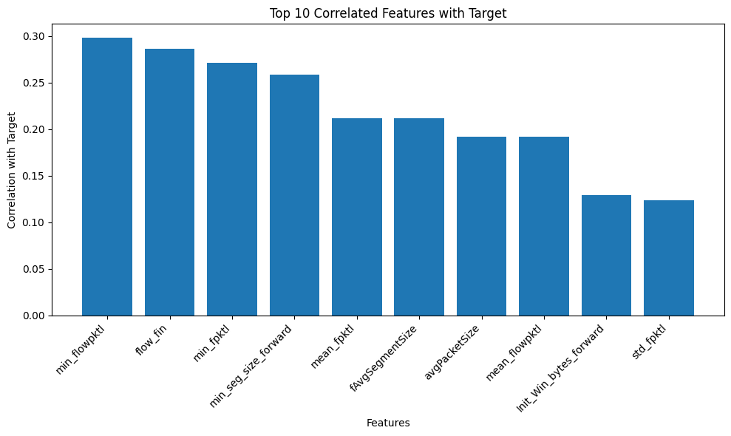

**Feature Selecting:**

It selects the top 50 most statistically important features from X based on the target y using SelectKBest with f_classif,

**Features importance:**

It calculates feature importance scores (ANOVA F-scores) using SelectKBest, sorts them, and plots a horizontal bar chart showing the most important features at the top

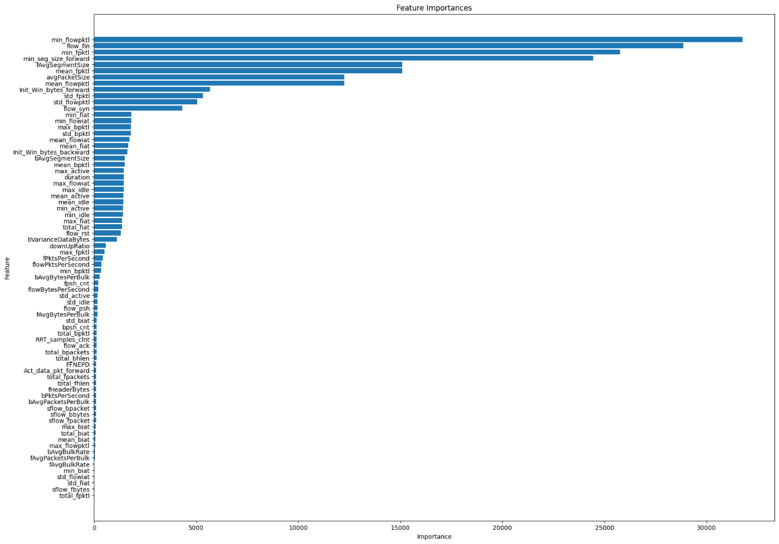

**Checking data imbalance:**

calss

2 471597

1 155613

0 4745

Name: count, dtype: int64

calss

2 74.625092

1 24.624063

0 0.750845

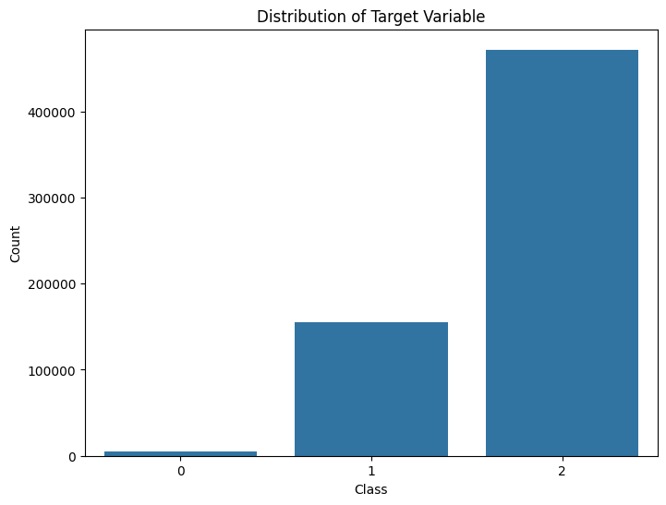

**Balance the data by using Smote**

calss

2 471597

1 471597

0 471597

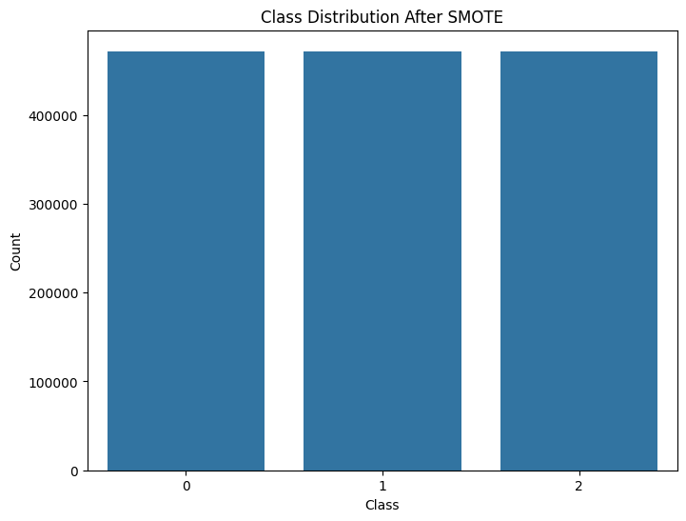

**Data Splitting:**

We split data into training and testing sets in the ratio of 80:20 .

80% for training and 20% for testing.

**Model implementation:**

**Random Forest**

Parameters=(n_estimators=500,max_depth=25,n_jobs=-1, random_state=42)

**Random forest Training Result**

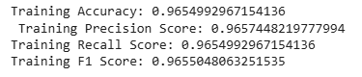

**Classification Report**

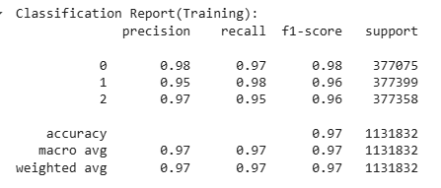

**Confusion Matrix**

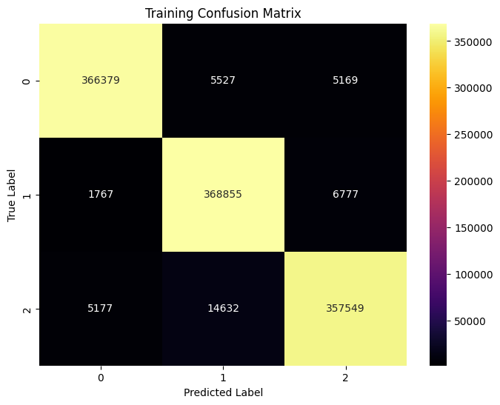

**Roc Curve**

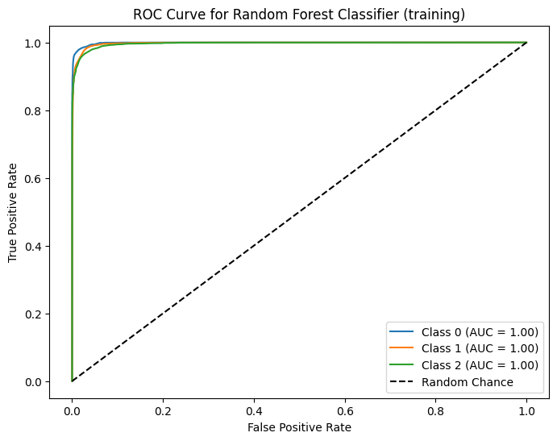

**RandomForest Test Result**

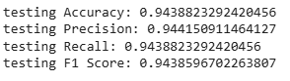

**Classification Report**

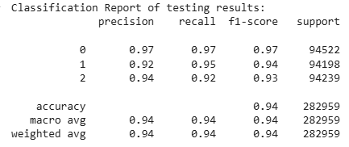

**Confusion Matrix**

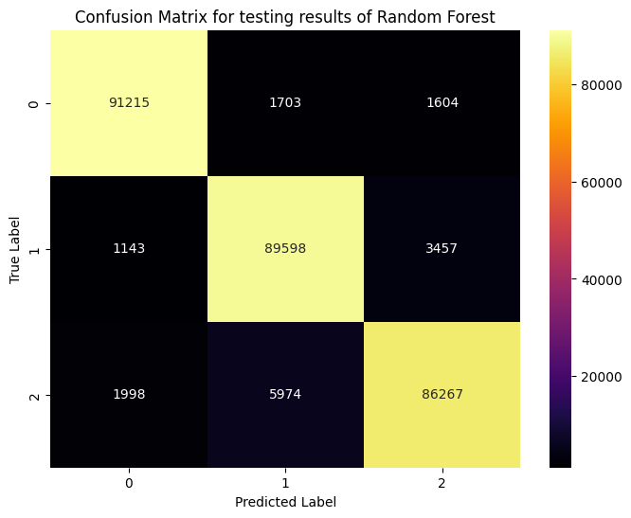

**Roc curve**

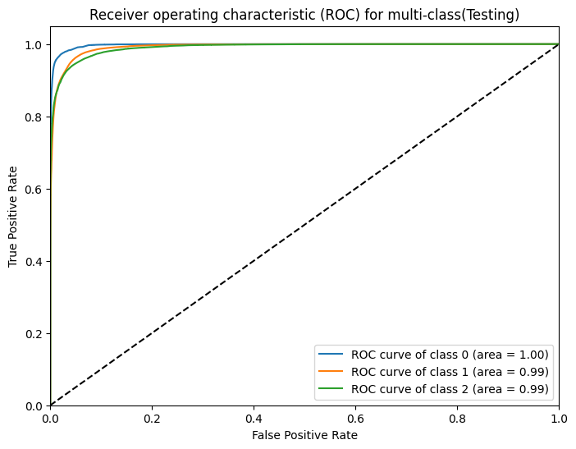

**Xgboost classifier**

Parameter: 

Training Result

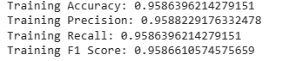

Classification Report

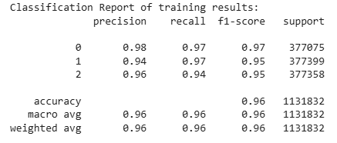

Confusion Matrix

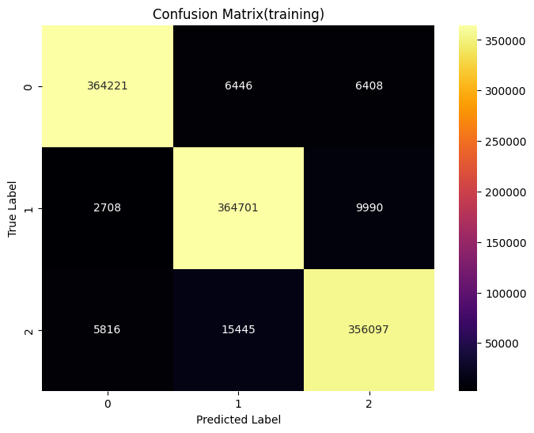

ROC Curve

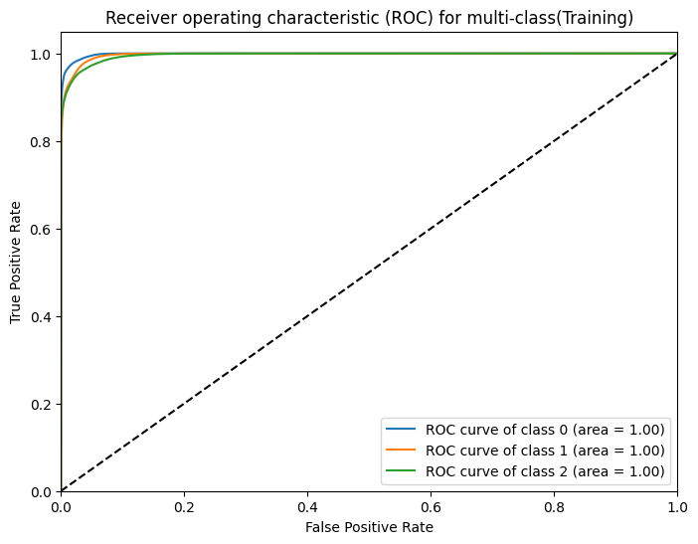

Xgboost Testing Result

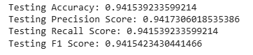

Classification Report

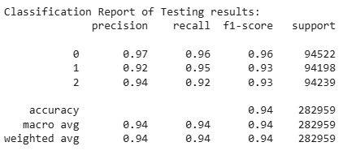

Confusion MAtrix

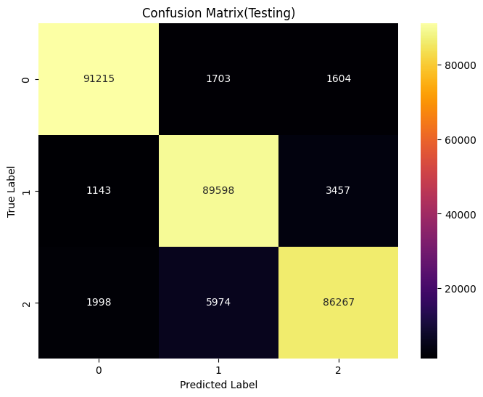

Roc curve

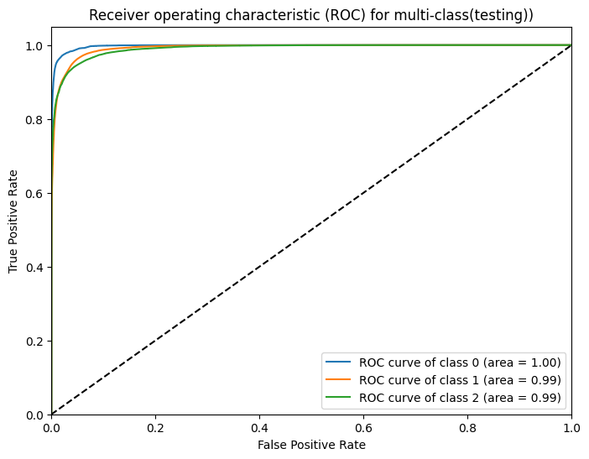

Comparision Graph:

